Detailed project report

**Objective:**

The purpose of this document is to provide the detailed insight on the methods of processing and the results as a report. It helps one to get the full insight into the FDI pattern and help to take the decision.

**Benefits**:

Once the data is received as a dataset in the form of CSV, we need to make it go through a set of preprocessing which will result in a cleaner data. This data can be further explored and meaningful insight can be derived out of it.

**Data Processing**

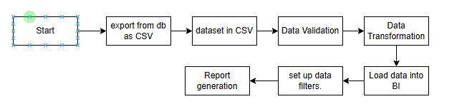

**Q & A:**

Q1) What’s the source of data?

The dataset has provided by iNeuron in single csv file. It contains the data of direct foreign investment for 10 years.

Q 2) What was the type of data?

The data was the combination of numerical value (representing the investment amount) and text for representing sector.

Q 3) What’s the complete flow you followed in this Project?

Refer Architecture flow chart for better Understanding

Q 4) Which data analytics tools used for generating report?

I used Power BI to generate the report by supplying the dataset.

**KPI and their details**

**In which sector investment was consistently increased over the years?.**

SERVICES SECTOR (Fin.,Banking,Insurance,Non Fin/Business,Outsourcing,R&D,Courier,Tech. Testing and Analysis, Other) - Service Sector has increase consistenly over year from 2013-2017, more investment coming from service sector

**Was there any decline of investments in any particular sector over the years?**

PORTS Sector - Decline of investments year from 2011-12 to 2016-17.

**In which sector investment is almost constant over the years?**

Service Sector, automobile industry, Telecommunication and Computer Software investment is almost constant over the years

**Is there any particular year in which one or more investments were below the average?**

5 Sectors are below average almost all the years:

COIR

Defence Industries

MATHEMATICAL,SURVEYING AND DRAWING INSTRUMENTS

Coal Production

PHOTOGRAPHIC RAW FILM AND PAPER

**Was there any sudden change(increase/decrease) in the investment during these years?**

In the year 2011-12, increased investment all the sectors, expect Automoble industry and MISCELLANEOUS INDUSTRIES

**Show me the top 5 sectors to invest in? Can you show the data to justify it?**

Services Sector

Computers Software & Hardware

Construction Development

Telecommunication

Automobile Industry